STAT 2023 Exercise Lesson 18.2 Name in clear print ____________________________________

Legal Signature ______________________________________

CWID write clearly ____________________________________
See the example beginning on page 9 in Lesson 18 for the complete illustration of this example.
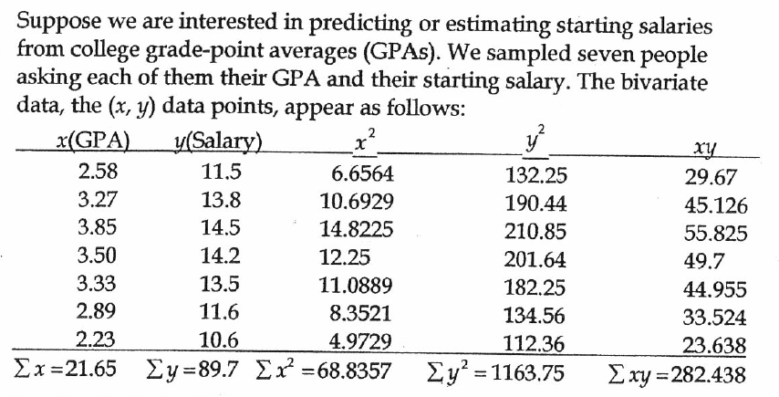
- What is the corrected sum of squares for the x-variable?

- What is the corrected sum of squares for the y-variable?

- What is the corrected sum of squares for the cross product?

- What is the least squares estimate of the slope in the linear regression equation to estimate the starting salary from GPA?

- What is the least squares estimate of the y-intercept in the linear regression equation to estimate the starting salary from GPA?

- Write the estimated regression equation to estimate the starting salary from the GPA.

- Use the estimated regression equation to estimate the average starting salary of students who have a 3.0 GPA.

- What is the estimated linear correlation? See page 9 of Lesson 18 for equation.

Lesson 18.2 exercise, page 2
- What is the estimated variance of the residuals? See page 9 of Lesson 18 for equation.

- What is the estimated standard error of the slope estimate? See top equation page 10 Lesson 18

- What is the 95% confidence interval that results from these data to estimate the slope?

- What is the set of hypotheses to test whether GPA affects starting salary?

- What is the test statistic to test the above null hypothesis

- What is the set of hypotheses to test whether a unit increase in GPA results in an average increase of more than $4,000 for starting salary?

- What is the test statistic to test the above null hypothesis?

- What is the conclusion of the test above?

